**Get the free update**

Ready? Now you can download the free update from the Windows Store.

1. Go to the Start screen, and tap or click the Store tile.

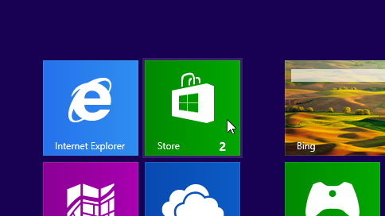Store tile on the Start screen

1. In the Store, tap or click the Windows 8.1 or Windows RT 8.1 update. if you don't see the update on the Store home screen, see [**Why can't I find the update in the Store?**](http://windows.microsoft.com/en-us/windows-8/why-can-t-find-update-store)
2. Tap or click **Download**.
3. The update will download and install in the background while you use your PC to do other things. The installer will check to make sure you have enough disk space, that your apps and devices will work with Windows 8.1 or Windows RT 8.1, and that you have all the required updates.

In some cases, the installer might find something you need to take care of before you can continue installing the update. If so, you'll see a message telling you what you need to do.

**Note**

* + If the installation is interrupted for any reason, you can restart the update from where you left off by going back to the Store and downloading the update again.

**4. Restart**

After the update is downloaded and the first phase of the installation is complete (which could take between 15 minutes and a few hours, depending on your system and your connection speed), you'll see a message telling you that your PC needs to restart. It will give you 15 minutes to finish what you’re working on, save your work, and close your apps, and then it will restart your PC for you. Or you can restart it yourself.

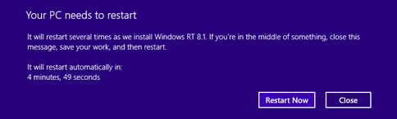Message warning of restart

Important

**Important**

* If you leave your PC before it's ready to restart, be sure to save your work and close any desktop apps you're using to make sure you don't lose anything when it restarts automatically. Your PC might need to restart more than once, depending on how it’s set up, and whether additional updates are needed.
* Restarting will take longer than usual—from 20 minutes to about an hour—while the update is applied. During this time, you won't be able to use your PC.

**5. Choose your settings**

**License terms**

After your PC finishes restarting, you'll be presented with the Microsoft software license terms. Review the terms, and then tap or click **I accept** to continue. If you don't accept the terms, this cancels the installation of Windows 8.1 or Windows RT 8.1, and your PC will roll back to Windows 8 or Windows RT.

**Express settings**

You'll see a list of recommended settings, called express settings. To accept these settings and continue, tap or click **Use express settings**. You can change any of these settings later, after you finish setting up. If you'd like to change some of these settings now, tap or click **Customize**.

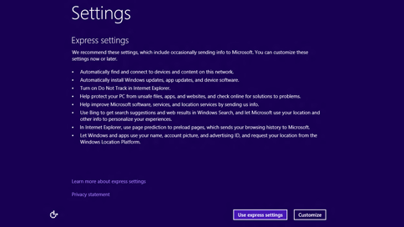Express settings shown during setup

For more info, tap or click **Learn more about express settings**. To learn about how these settings affect your privacy, tap or click **Privacy statement**.

**Sign in**

Next, you'll be asked to sign in.

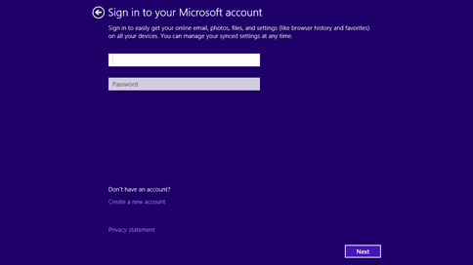Signing in with a Microsoft account

If you already use a Microsoft account to sign in to Windows 8 or Windows RT, your account name will be filled in for you. If you previously used a local account for this, you'll need to sign in with your local account first, and then we'll ask you to set up a Microsoft account, which you can use to sign in to your PC after the update.

[**Show all**](http://windows.microsoft.com/en-us/windows-8/update-from-windows-8-tutorial)

**[http://res1.windows.microsoft.com/resources/4.1/wol/shared/images/merged/expcol_imgs.png](http://windows.microsoft.com/en-us/windows-8/update-from-windows-8-tutorial)**[**If you already have a Microsoft account**](http://windows.microsoft.com/en-us/windows-8/update-from-windows-8-tutorial)

1. Enter your Microsoft account email address, if needed, and your password.
2. We'll send a security code to the alternate email address or phone number you've set up for this account, and you'll need to enter that code to verify that you're the owner of the account. This helps us protect your account and devices when you access sensitive info. If you don't have alternate contact info set up for the account yet, you'll be asked to provide it now.

**Notes**

* + If you have more than one Microsoft account, you can get help figuring out [which email address to use for yourMicrosoft account](http://windows.microsoft.com/en-us/windows-8/which-email-for-microsoft-account).
  + If you signed in to your PC using a Microsoft account before you installed Windows 8.1 or Windows RT 8.1, then you might not need to enter a security code.

**[http://res1.windows.microsoft.com/resources/4.1/wol/shared/images/merged/expcol_imgs.png](http://windows.microsoft.com/en-us/windows-8/update-from-windows-8-tutorial)**[**To create a new Microsoft account**](http://windows.microsoft.com/en-us/windows-8/update-from-windows-8-tutorial)

1. Choose **Create a new account**.
2. Next, you'll be asked to choose an email address you'd like to use as a Microsoft account. This can be any email address you use, and isn't limited to addresses that come from Microsoft. Enter the email address that you use the most. We'll use it to set up the Mail and People apps for you with email and contacts that you already use every day.
3. Enter the password you'd like to use, and fill in the rest of the info, including your first name, last name, and your country or region.
4. Next, you'll also be asked to provide an alternate email address or phone number where we can reach you by email, phone, or text message (SMS). This helps us protect your account and devices whenever you access sensitive info using this account. After you enter this info, we'll send a message to you containing a security code, and you'll need to enter that code to verify that you're the owner of the account.

**[http://res1.windows.microsoft.com/resources/4.1/wol/shared/images/merged/expcol_imgs.png](http://windows.microsoft.com/en-us/windows-8/update-from-windows-8-tutorial)**[**To keep using a local account**](http://windows.microsoft.com/en-us/windows-8/update-from-windows-8-tutorial)

**SkyDrive cloud storage**

If this is your first time setting up a PC with Windows 8.1 or Windows RT 8.1, you'll see the new SkyDrive options.

If you already have another PC running Windows 8.1 or Windows RT 8.1, and you chose to sync settings on that PC, then yourSkyDrive settings will also sync from your existing PC to this one, and you might not see this screen.

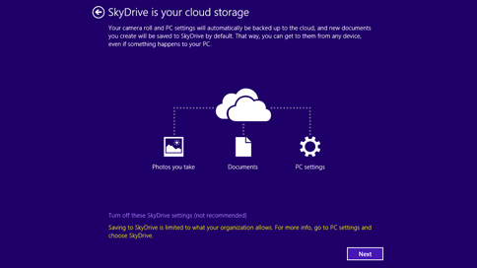SkyDrive options during setup

If you click **Next** on this screen, your PC will use these default SkyDrive settings:

* Photos you take with this PC are saved to your camera roll folder on this PC, and a smaller copy of each photo is automatically backed up to your SkyDrive.
* When you create a new document, the default save location is SkyDrive. But you can always choose to save individual documents locally or on another drive.
* Windows will save a backup copy of your PC settings to SkyDrive. If something ever happens to your PC and you need to replace it, your settings are saved in the cloud and you can transfer them to a new PC instantly.

You can change any of these settings later in PC settings. If you'd prefer to turn off all of these settings now, tap or click **Turn off these SkyDrive settings (not recommended)**.

**Final updates**

Because Windows is always being updated, it’s possible that critical updates have become available since Windows 8.1 andWindows RT 8.1 were finalized. Windows checks for these critical updates when you finish setting up Windows 8.1 orWindows RT 8.1 for the first time, and if it finds any, it will download them automatically. Downloading and installing these updates might take a few minutes, depending on the updates you need. Your PC might also need to restart one or more times to complete the updates.

**6. Welcome to the new Windows**

The new Start screen will appear.

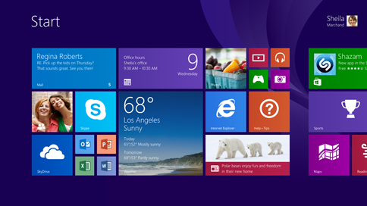The new Start screen

Much of it will look familiar, but if you'd like to explore what's new and how to get around, check out this [**Start screen page**](http://windows.microsoft.com/en-us/windows-8/start-screen-tutorial).

Your desktop apps come with you when you update to Windows 8.1, but you'll need to reinstall your Windows Store apps. You can see all of the Windows Store apps you own in the **Your apps** section of the Store. From here, you can choose the ones you want to install on your updated PC, and install them all at once.